# Temperature-Controlled Fan Project

## 1. Project Overview

The Temperature-Controlled Fan is designed to automatically adjust the fan speed based on the surrounding temperature. This project uses an Arduino Uno, DHT22 temperature sensor, LCD display with I2C module, and a motor driver to regulate the speed of a DC fan.

## 2. Components and Tools Used

• Arduino Uno  
• DHT22 Temperature Sensor  
• LCD Display (I2C module, address 0x27)  
• Motor Driver (without ENA pin)  
• DC Motor with fan  
• Jumper wires and breadboard  
• Arduino IDE for programming

## 3. Project Objective

The main objective of this project is to automatically control the speed of a fan according to the measured room temperature, thereby maintaining a comfortable environment and improving energy efficiency.

## 4. Circuit Diagram

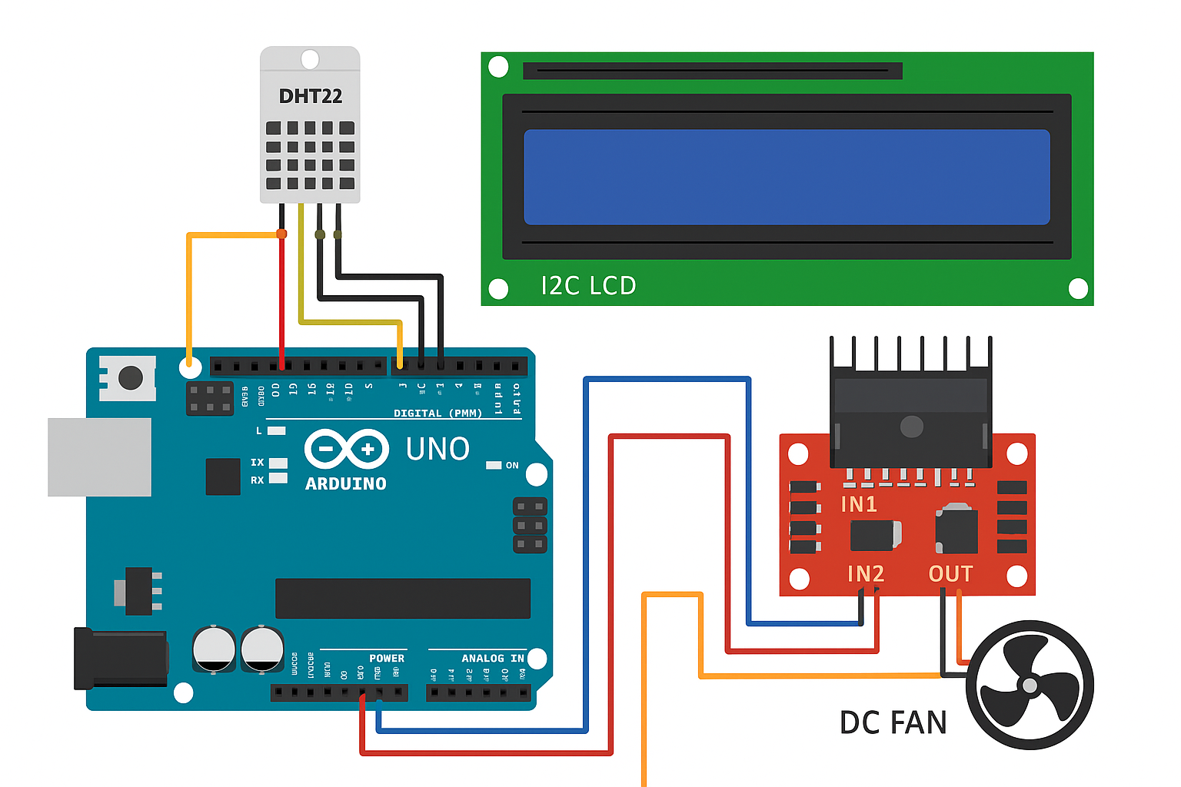

## 5. Code Explanation

The Arduino reads temperature data from the DHT22 sensor and displays it on the LCD. Depending on the temperature, the Arduino adjusts the PWM signal to the motor driver to control fan speed.  
  
Main functions:  
• Reads the current temperature.  
• Controls fan speed using PWM.  
• Displays temperature on the LCD screen.

## 6. Results and Observations

The system successfully adjusts fan speed based on temperature. The LCD display shows real-time temperature readings. Testing confirmed that higher temperatures result in higher fan speeds, and the fan stops when the temperature falls below the threshold.

## 7. Learning Outcomes

Through this project, the following concepts were learned and applied:  
• Interfacing sensors and actuators with Arduino  
• Pulse Width Modulation (PWM) for motor control  
• I2C communication protocol for LCD display  
• Debugging sensor errors and wiring issues  
• Basic control systems for automation

## 8. Future Improvements

• Add IoT functionality to send temperature data to ThingSpeak for online monitoring.  
• Implement a mobile dashboard to view temperature in real time.  
• Use a servo motor to control airflow direction.  
• Integrate the system into a smart home setup.

## 9. Conclusion

This project demonstrates a simple yet effective application of mechatronics principles — combining sensors, microcontrollers, and actuators. It provides a foundation for developing more advanced automation systems, such as IoT-enabled smart cooling systems.

